# Exploring GIT with Github

My repository -> <https://github.com/kleven11/hello>

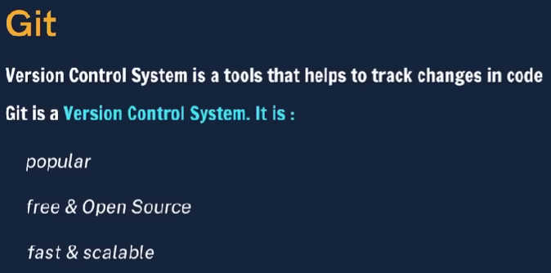

Geeks for geeks cheat sheet => <https://www.geeksforgeeks.org/git-cheat-sheet/>

